Fluency  6 points | Smooth reading  Unnecessary stops =  Stutters = | /2  /2  /2
Accuracy  15 points | Incorrect words =  Skipped words =  Added words = | /5  /5  /5
Expression  8 points | Excitement at exclamations  Stopped at periods  Paused at commas  Voice raised at questions | /2  /2  /2  /2
Presentation  25 points | Memorized script  Eye contact  Posture  Volume  Facing audience | /5  /5  /5  /5  /5
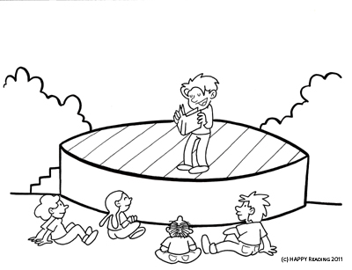

Total: /54

