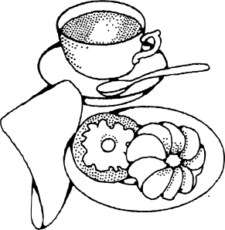
Dear family,
Poetry has been known to greatly assist children in their reading fluency; therefore we will be starting a poetry unit this week. Every week the students will be assigned a poem that they are expected to read at home in a variety of creative ways (see below). These at home activities are made to be fun and creative. I encourage you to participate with your child in these assignments. My hope is that every student will be reading a little more fluently by December.
3rd Grade Poetry Assignments
Monday | Read poem in the mirror 5 times, try to look up at yourself as much as possible
Tuesday | Call a relative (preferably grandma or grandpa) and read them your poem
Wednesday | Record yourself reading your poem on the computer, using a camera, or on your parent’s cell phone. Listen to your recording and critique yourself.
Thursday | Be prepared to read your poem to a buddy at school
Friday | Be prepared to present your poem to the class during poetry café!

Every Friday the students will present their poems to the class in a weekly poetry café. This period is meant to be fun, relaxing and enjoyable for the kids. I want to recreate the classroom to resemble a real café as much as possible. I will need your help to make this happen; therefore every family will be responsible for providing a small snack and beverage for Friday’s poetry café. Please make a note of the week your family is assigned café duty. Feel free to attend the poetry café at any time! We would love having you
Café Duty
Please do not bring any egg or nut products, we have students with these allergies.
Date | Family
September 21 | Miss Jenkins & Wallace
September 28 | Bernard & Williams
October 5 | Czaykowsky
October 12 | Goode
October 26 | Gravesande & Ravenall
November 2 | Guillen & Meija
November 9 | Knight
November 16 | Lewis
November 30 | McCourty
December 7 | Sailes
December 14 | Villegas

Please bring the following on your assigned date. There should be enough for 17 students. I will provide cups.  - Snacks/pastries  - Small Plates  - Napkins  - Light beverage | Appropriate finger food and beverage ideas include:  - Sweet tea  - Donuts  - Crackers & cheese  - Fruit  - Veggies & dip  - Hummus & veggies/fruit/crackers  - Hot coco  - Chocolate milk

