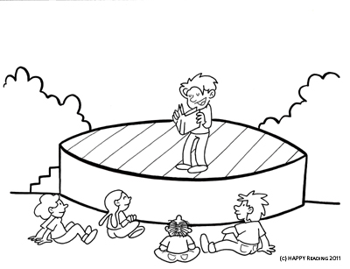
Dear family,
Theatre has been known to greatly assist children in their presentation skills and confidence building; therefore we will be starting a theatre unit this semester. Every week the students will be assigned a script that they are expected to read at home in a variety of creative ways (see below). These at home activities are made to be fun and creative. I encourage you to participate with your child in these assignments. My hope is that every student will be reading a little more fluently by
May.
3rd Grade Theatre Assignments
Monday | Read script in the mirror 5 times, try to look up at yourself as much as possible
Tuesday | Read your script with a relative, remember to use expression
Wednesday | Record yourself reading your script on the computer, using a camera, or on your parent’s cell phone. Listen to your recording and critique yourself.
Thursday | Be prepared to perform your part with your reading group at school
Friday | Be prepared to present your script to the class during reader’s theatre!

Every Friday the students will present their skits to the class in a weekly reader’s theatre. This period is meant to be fun, relaxing and enjoyable for the kids. I want to recreate the classroom to resemble a theatre as much as possible. I will need your help to make this happen; therefore every family will be responsible for providing a small popcorn snack and beverage for Friday’s reader’s theatre. Please make a note of the week your family is assigned theatre duty. Feel free to attend our reader’s theatre at any time! We would love having you
Theatre Duty
Please do not bring any egg or nut products, we have students with these allergies.
Date | Family
January 18 | Wallace
January 25 | Bernard
February 1 | Czaykowsky
February 8 | Goode
February 15 | Gravesande
February 22 | Guillen
March 1 | Knight
March 8 | Lewis
March 22 | McCourty
March 29 | Sailes
April 5 | Villegas
April 12 | Williams
April 19 | Meija

